**STEP-1 SETUP THE FIREWALL:**

117.241.145.154 ye humari public ip hai Amritsar ki

wan port

WAN PORT2

FIREWALL

192.168.1.4, 255.255.255.0, 192.168.1.1

SWITCH

172.16.16.16,255.255.255.0,172.16.16.1 (default)

LAN PORT1

192.168.40.1, 255.255.255.0 (static)

Ab jo humara Lan port hai firewall ki tarah ye gateway ka kaam karega isliye humne 192.168.40.1 karenge. iski ip pahle 172.16.16.16 rhti hai.. isko humne change kar diya so ab humara firewall is ip se open hone lagega browser me. Just type <https://192.168.40.1> in the browser

SYSTEM

192.168.1.237,255.255.255.0, 192.168.1.1

Step 1. First connect the modem wan port to firewall wan port and the lan port is connected to the switch. Switch is also connected with the modem so that switch can communicate. The firewall default ip is 172.16.16.16 and my computer ip is 192.168.1.237. so if I want to open the firewall it will not open because our ip address is different class and I also don’t want to change my server ip address because the internet will be off ,if I do that because my modem ip is different. So ye ip ping nahi hoga kyuki iska class change ho gya so hume is ip ko add karna padhega advanced tcp/ip ki settings me jakar add karna hoga in ip ko ipv4 me ip- 172.16.16.16 , subnet mask- 255.255.255.0 and gateway- 172.16.16.1

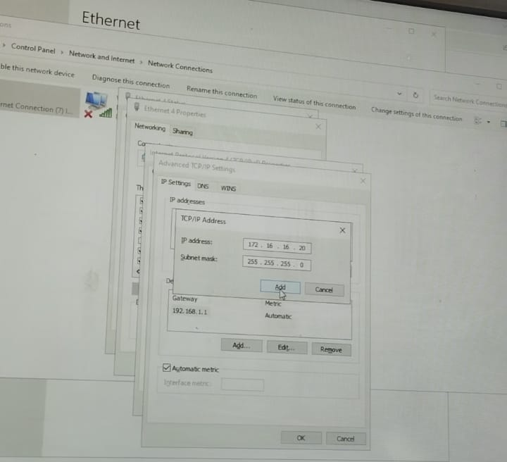

So before moving further we need to know every thing like

Humare system ki ip 192.168.1.237, subnet mask- 255.255.255.0, gatewat- 192.168.1.1………………….. humare firewall ki static ip 192.168.40.1 hai so hum iske liye bhi ipv4 add krenge apne system me

Aur hum apne system ke advanced ipv4 me jakar is ip-192.168.40.100, subnet mask- 255.255.255.0, gateway- 192.168.40.1 ko add krenge.

1. System ip- 192.168.1.237, subnet mask- 255.255.255.0, gateway- 192.168.1.1
2. Firewall ip- 172.16.16.16, subnet mask- 255.255.255.0, gateway- 172.16.16.1 jisko hum change karenge 192.168.40.1 se so ab humara is new ip se firewall open hoga…
3. Firewall me LAN AUR WAN port KI IP:

Port1 (LAN) –static ip- 192.168.40.1 , subnet mask- 255.255.255.0…. iska matlab ki jo humara firewall pahle 172.16.16.16 se open ho rha tha wo firewall ab 192.168.40.1 ki ip se open hoga

Port2(WAN)- ip – 192.168.1.4 , subnet mask- 255.255.255.0

1. ISP 172.16.16.16 ye ip humare website ki hai jisko hum apne system me open karna chahte hai

Step 2: firewall ko open karne ke liye browser me jayenge aur <https://172.16.16.16> type karenge to hi humara site open hoga… yad rahe https lgane par hi open hoga agr hum http likh kar open krenge to open nahi hoga kyuki ye secured rhta hai

a). sabse pahle hum apna Sophos firewall ko login karenge username – admin aur password admin likhenge agr login failed btata hai to hume apne firewall ka setup starting se karna padhega. Aur apna username aur password yad rakhna hoga usi username aur password se Sophos ka dashboard open hoga

b) sabse pahle hum rules and policies>add firewall rule>server access assistant(DNAT) me jayenge aur create ip host par click karenge 117.241.145.154- internet server likhenge uske bad next par click karenge iske bad public ip address puchega waha par hum #port2 192.168.1.4 iske bad next par click karenge to server access assistant open hoga usme hume https ko select karna hai. Uske bad next par click krenge to external source devices and resources puchhega to usme hum ANY likh denge.

So yeh humara first steps complete ho jayega….. hum apne screenshot me ye sara process dekh sakte hai

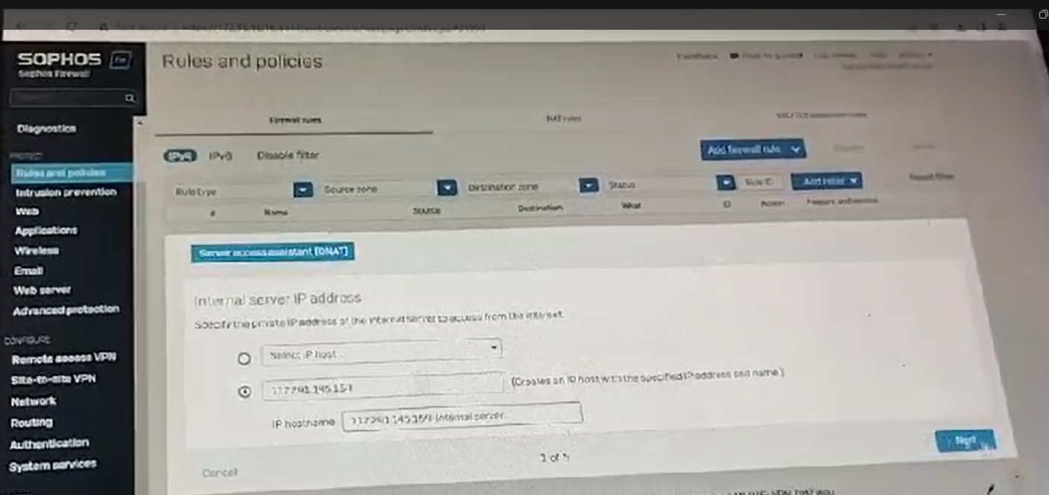



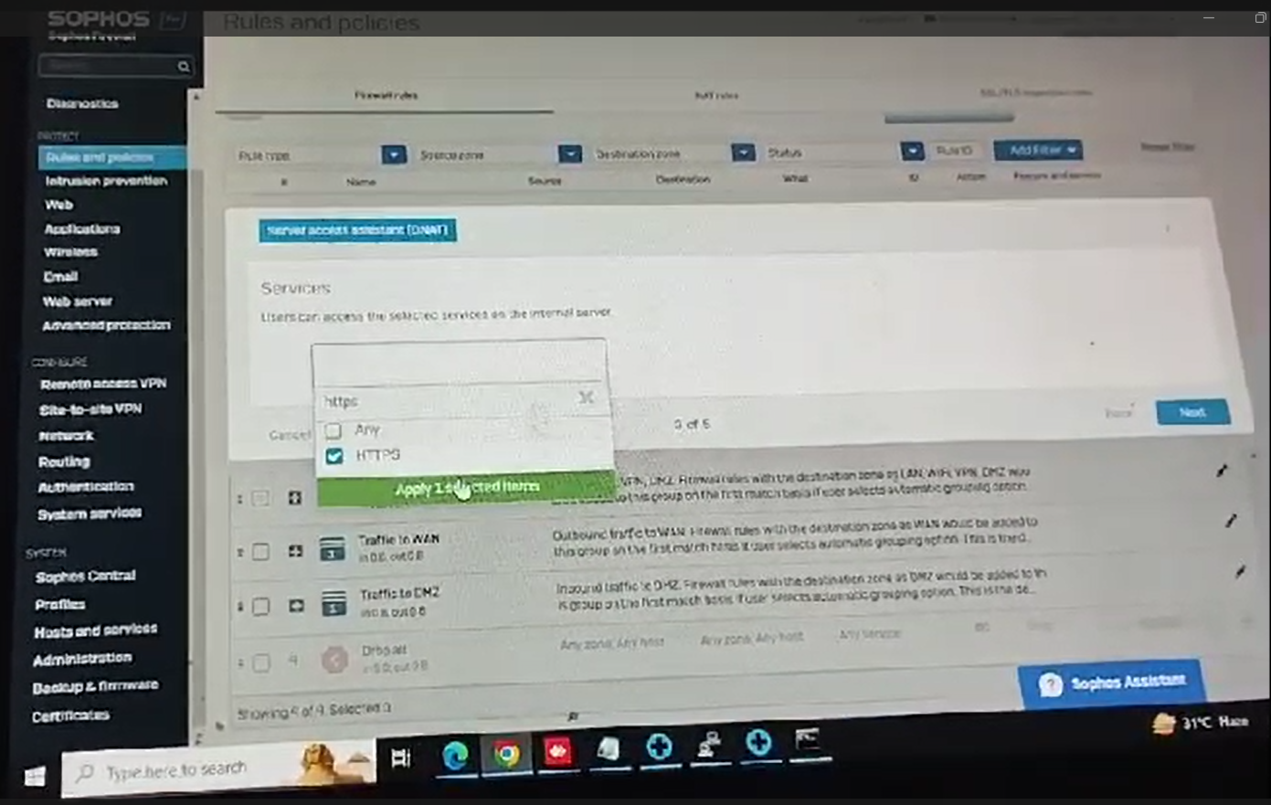

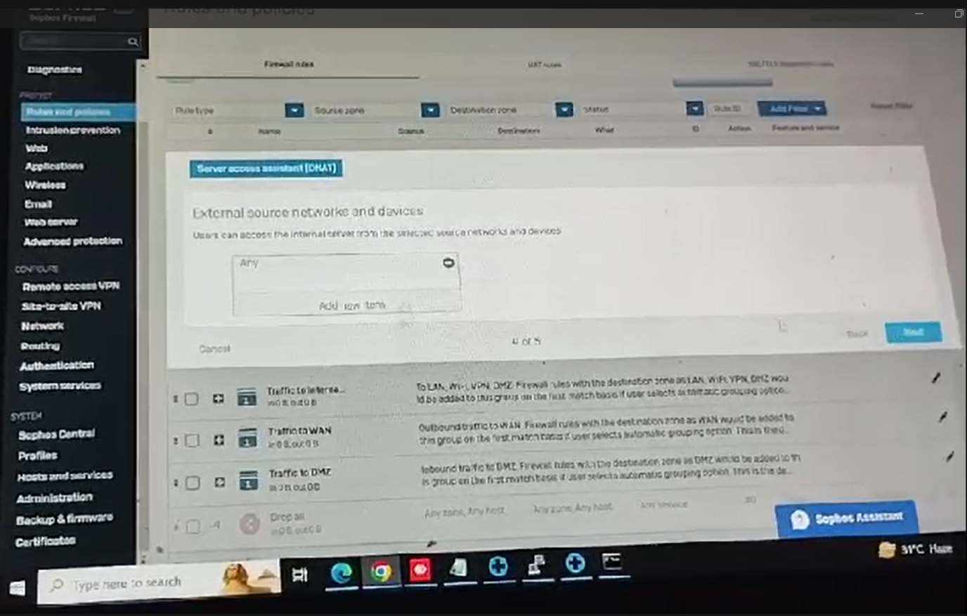

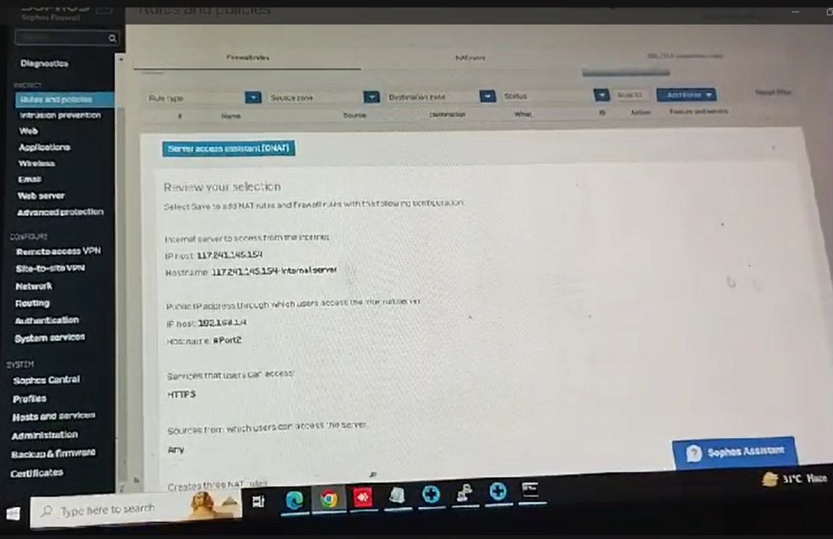

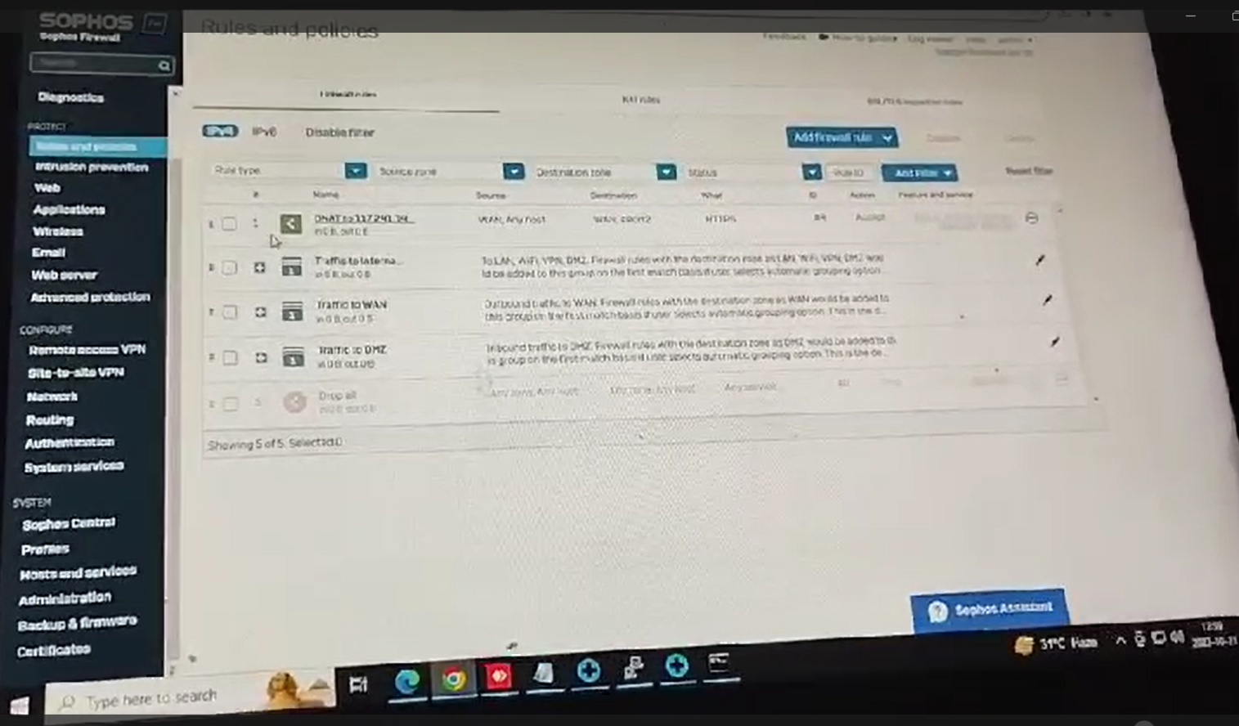

So when we reached here it means our first step is completed

1. Internet server to access from the internet

IP HOST: 117.241.145.154

Hostname: 117.241.145.154-internet server

1. Public ip address through which user access the internet server

IP Host: 192.168.1.4

Hostname: #port2

1. Services that can user can access: HTTPS
2. Sources from which user can access the server: Any
3. Creates three nat user
4. Inbound nat(DNAT):

Step2: ab hum network section me interface me jayenge means network>interface>name- port1> network name- LAN check the ipv4 configuration> ip assignment- static > ipv4 interface 192.168.40.1 sybnet mask /24 255.255.255.0..

So ye ip ping nahi hoga kyuki iska class change ho gya so hume is ip ko add karna padhega advanced tcp/ip ki settings me jakar add karna hoga in ip ko ipv4 me ip- 192.168.40.100 , subnet mask- 255.255.255.0 and gateway- 192.168.40.1….. isme hum apne system ki ip bhi dalenge jo ki ip- 192.168.1.237 , subnet mask- 255.255.255.0 and gateway 192.168.1.1

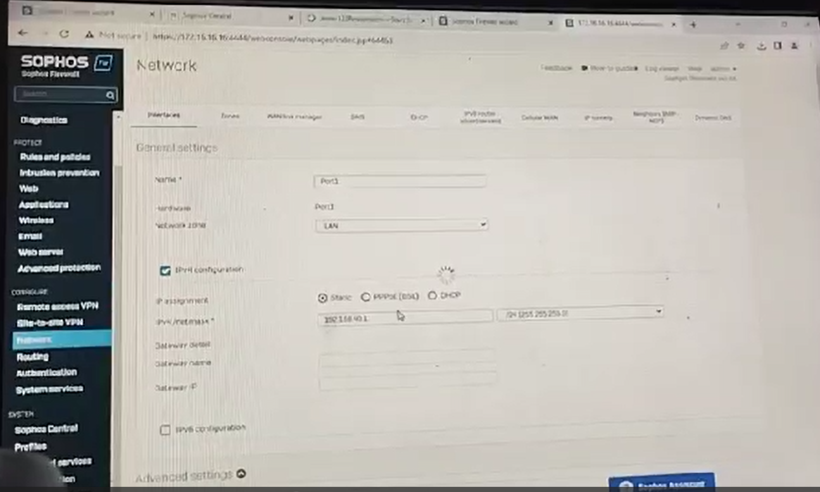

Itna chiz complete karne ke bad agar hum apne system ke browser me <https://192.168.40.1> ye likhte hai to ab humara firewall is ip se khulne lagta hai jo ki pahle 172.16.16.16 wali ip se khul rha tha..

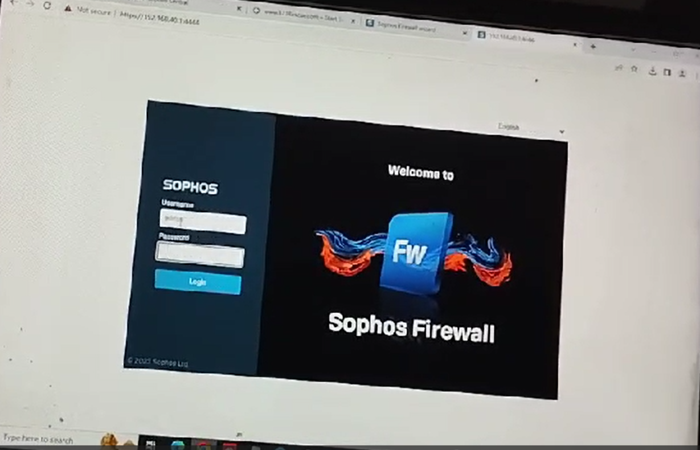

Hum browser me ip dekh sakte hai ki humara firewall ab kis ip se open ho rha hai…

Step-3: so upar wale steps tak humne apne public ip ka setup kar diya hai aur apne firewall ko ek static ip par chala diya hai lekin abhi humare system me internet nahi chal rha hai firewall ke through. So hume apne system me internet chalana hoga firewall ke through. Hum ping karke check bhi kar sakte hai apne system me net chal rha hai ya nahi. Agar hum ping 8.8.8.8 ko ping karenge to dekhenge ki ye ping nahi ho rha hai abhi.

Rules and policies> add firewall rule>new firewall rule>

Rule name- LAN_WAN, rule position- top, rule group – None aur firewall log me check sign kar denge ab niche sources me aayenge

Source name-LAN

Destination name- WAN

Iske bad hum translation setting me> translated source(SNAT)- MASQ ko select krenge aur save karenge iske bad other security wala page open hoga save kar denge iske bad humari sari settings ho gayi hai. Ab hum agar apna firewall rule ko open kare to dnat ke upar lan_wan wala hume dikhayi dena chahiye kuch is tarah se.

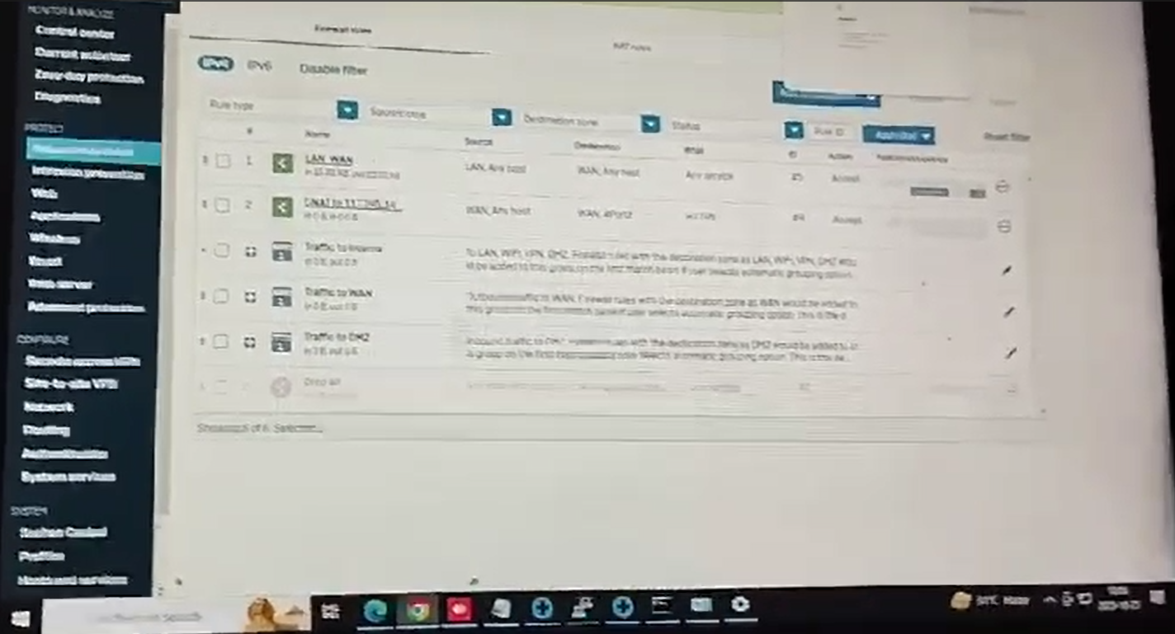

Aur agar hum apne network me jaye firewall ke to hume is tarah se dikhayi dena chahiye…

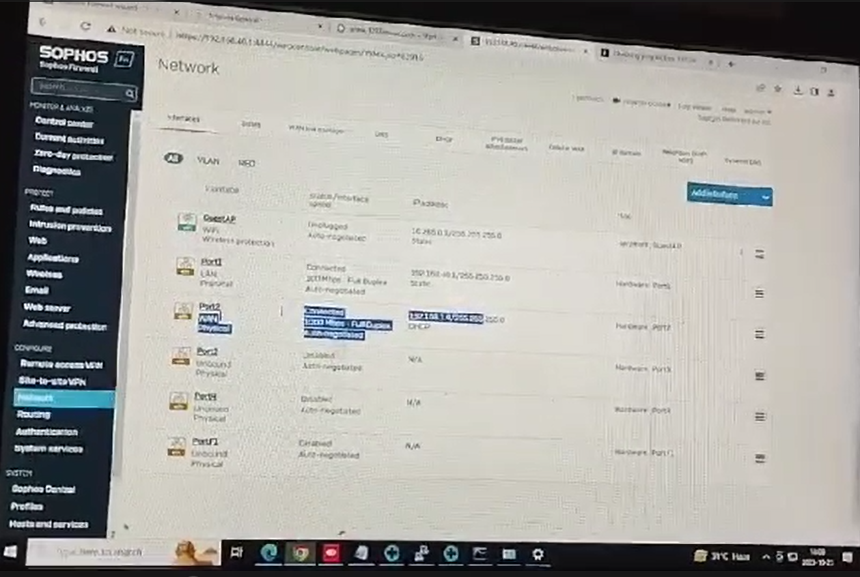

So agar hume itna sab dikh rha hai means humara setting complete ho gya hai. Aur isme firewall ke through net bhi chalna start ho jayega….

Port1 (LAN) – ip- 192.168.40.1 , subnet mask- 255.255.255.0…. iska matlab ki jo humara firewall pahle 172.16.16.16 se open ho rha tha wo firewall ab 192.168.40.1 ki ip se open hoga… aur is lan port ke through ye humare system se connect rhega.

Port2(WAN)- ip – 192.168.1.4 , subnet mask- 255.255.255.0… is wan port ke through ye humare ISP se connect hoga jo humare public address ko access karega

NOTE- so humare system se jiski ip 192.168.1.237 hai isse ye humare firewall ke lan port jisko hum port1 bolte hai uski ip 192.168.40.1 hai isse connection banayega…. Iske bad humara lan port is firewall ke WAN port jisko ki hum port2 bolte hai 192.168.1.4 ye public ip hai kyuki wan hai isse connection banayega iske bad humara jo WAN port hai wo ISP(INTERNET SERVICE PROVIDER) se connect karega jiski ip humne 117.241.145.154 ye humari public ip hai isko access karega…

**Note- notedown one thing the router or modem should be in bridge mode and we need to take the ssid name and password of this which is used in the setup of the firewall. After setting up the everything we need to go port checker and check 443 port is opened or not. We also check our wan ip when I search what is my ip. It will show my wan ip in the internet.**

**Also setup the xamp server running on your local ip with port 443. This is must**

Step-2 How to Create Valid SSL in localhost for XAMPP

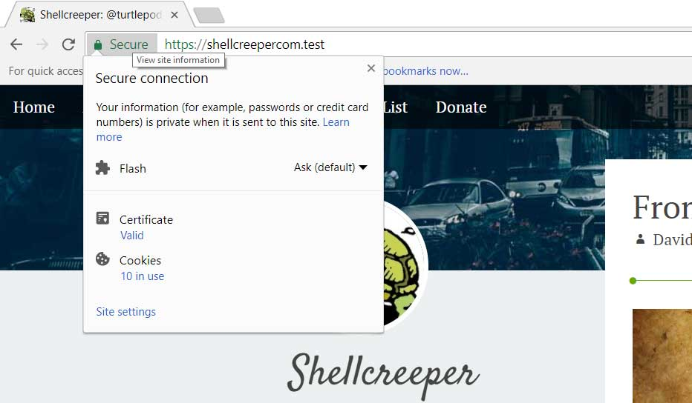

Is website me jayenge ye hume steps bta dega ssl certificate ko apne apache server me kaise install karte hai. So humara steps ka start is tarah se hota hai.

1. Sabse pahle hum ek ssl certificate ko install krna hoga apne cpanel me certificate ko install krenge. Cpanel me install krne ke bad waha se hum ek zip folder download krte hai jisme three files hoti hai .crt, .pem, gd_bundle.crt. waise isme main crt file humari .crt wali hoti hai. Itna karne ke bad inme se koi bhi chiz humare use ki nahi hai so hum in sare files aur folder ko delete mar denge jo ki hum cpannel se download kiye the.
2. Ab hum apne laptop me openssl ko download krenge aur isme se hum .crt aur .pem ki files ko generate krenge. Aur ye jo .crt aur .pem ki file hai ye hi humari python wale code me bhi use hongi jo sign in request ka kaam karti hai. Aur ye dono files hi humari C:\xampp\apache\ssl\fastagudaipur.aaieparking.com is folder me jakar rakh denge agar ye folders nahi honge to hume ye folder banana hoga aur apne crt ko install kar denge yaha par. Lekin crt ko install karne se pahle hum is folder me jayenge aur jo httpd-xamp.conf files hai usko open krenge. C:\xampp\apache\conf\extra\httpd-xampp.conf

Is file me sabse niche jakar hum ye lines add kar denge

<VirtualHost *:443>

DocumentRoot "C:/xampp/htdocs"

ServerName fastagudaipur.aaieparking.com

ServerAlias *.fastagudaipur.aaieparking.com

SSLEngine on

SSLCertificateFile "C:\xampp\apache\ssl\fastagudaipur.aaieparking.com\domain.crt"

SSLCertificateKeyFile "C:\xampp\apache\ssl\fastagudaipur.aaieparking.com\domain.key"

</VirtualHost>

**NOTE-** ye sara setup karne ke bad hum crt wali file jo hai ssl me usko install kar lenge. Install karne ke sare steps niche likhe hue hai.

**Note-** how to convert .crt file to .txt using openssl software…………….. sabse pahle to mai ye bta dena chahta hu ki confirmation ke liye ki ye jo openssl hai ye koi python ka package nahi hai ye bilkul alag hai humare python se to hum pip install openssl karke isko download nahi kar sakte kyuki ye python ka koi package nahi hai. Lekin agar hume openssl ko apne python code me use karna hai kahi to usko hum install kar sakte hai pip install pyOpenSSL ke naam se….. so aisa karne par hume python ka code likhna hoga .crt ko .txt me convert krne ke liye aur .crt aur .pem files ko generate karne ke liye. Lekin aisa hum nahi chahte hai ki hum python me jakar code likhe. So hum apne windows ke liye openssl ko google se download karne ke bad install kar lenge.

so sabse pahle hum apne computer me openssl ko install karenge windows 64 ke liye. Install hone ke bad agar hum cmd me jakar likhe openssl –version to ye hume version nahi dikha rha hai. Hum environment me path add karke bhi dekh chuke hai. So hum apni files me jayenge jaha par humara openssl install hokar uski files bani hai. Mere computer me ye C:\Program Files\Common Files\SSL yaha par hai lekin .exe ki file nahi hai so hum isse iska version nahi dekh sakte hai.

So openssl ka version dekhne ke liye hum windows search button par openssl search krenge to win64 openssl command prompt likhkar aisa aayega. Isko hum open kar lenge aur jab ye open ho jayega to ab agar hum yaha likhenge openssl version to hume iska version dekhne ko mil jayega.

**Win64 OpenSSL Command Prompt**

**OpenSSL 3.1.4 24 Oct 2023 (Library: OpenSSL 3.1.4 24 Oct 2023)**

**built on: Wed Nov 1 21:33:25 2023 UTC**

**platform: VC-WIN64A**

**options: bn(64,64)**

**compiler: cl /Z7 /Fdossl_static.pdb /Gs0 /GF /Gy /MD /W3 /wd4090 /nologo /O2 -DL_ENDIAN -DOPENSSL_PIC -D_USING_V110_SDK71_ -D_WINSOCK_DEPRECATED_NO_WARNINGS -D_WIN32_WINNT=0x0502**

**OPENSSLDIR: "C:\Program Files\Common Files\SSL"**

**ENGINESDIR: "C:\Program Files\OpenSSL\lib\engines-3"**

**MODULESDIR: "C:\Program Files\OpenSSL\lib\ossl-modules"**

**Seeding source: os-specific**

**CPUINFO: OPENSSL_ia32cap=0xfffaf38fffebffff:0x9c6fb9**

**C:\Users\Gourav>openssl version**

**OpenSSL 3.1.4 24 Oct 2023 (Library: OpenSSL 3.1.4 24 Oct 2023)**

**Note:** ab hume humara jo .crt ko .txt me convert karna hai to hum simply humari files jisko convert karna jaise domain.crt kaha hai waha par jayenge cd command se.

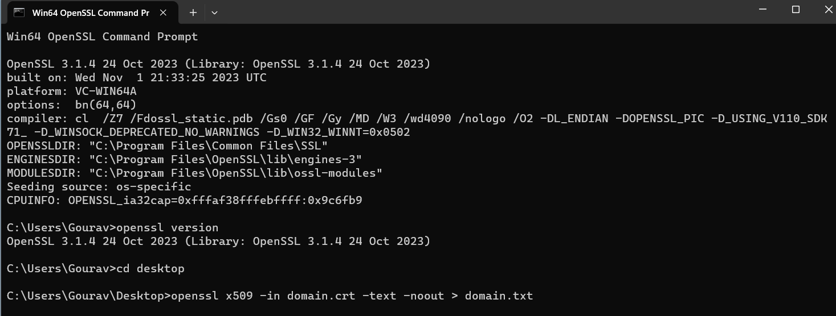

So humara jo domain.crt file thi wo desktop me thi so humne pahle cd desktop likha uske bad ye command chala diya

**Cd desktop**

**openssl x509 -in domain.crt -text -noout > domain.txt**

so desktop par hi humara domain.txt file ban jayegi. Us file me – begin certificate se pahle ka sara chiz hata dena hai aur is domain.txt ki jo file hai ise vikram ko send karna hai.

1. Agar hume .crt aur .pem ki file generate karni hai to hum ye command likhenge

**openssl req -new -newkey rsa:2048 -nodes -keyout my_key.pem -x509 -days 365 -out my_certificate.crt**

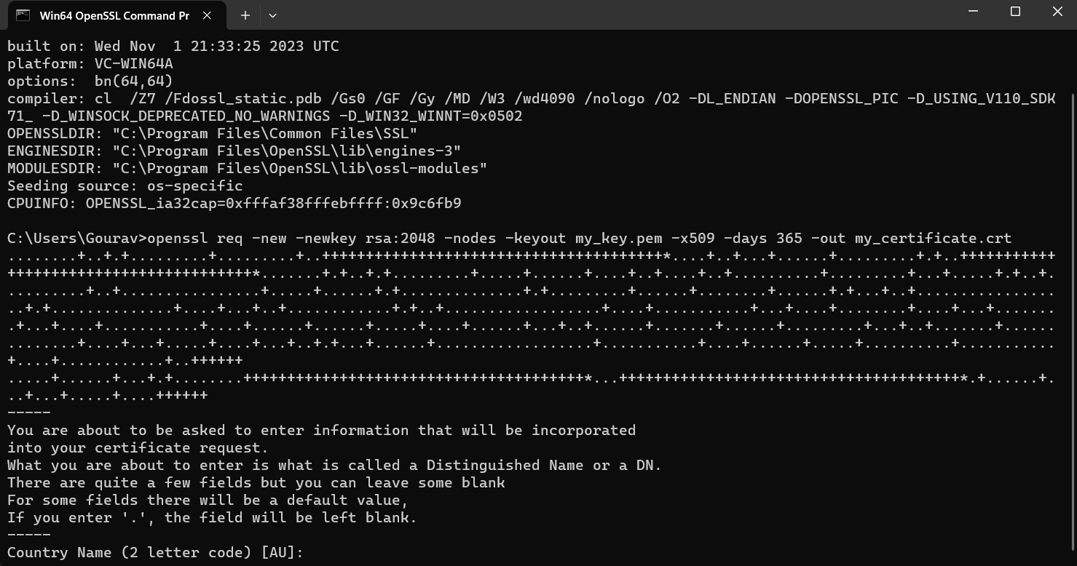

Note- hum python me code likhkar bhi .crt aur.pem file ko generate kar sakte hai. Lekin iske liye humare system me pip install pyopenssl, pip install cryptography ko install kar lenge. Itna karne ke bad hum apne python ka code likhenge.

**from cryptography import x509**

**from cryptography.hazmat.backends import default_backend**

**from cryptography.hazmat.primitives import hashes**

**from cryptography.hazmat.primitives import serialization**

**from cryptography.hazmat.primitives.asymmetric import rsa**

**from datetime import datetime, timedelta**

**def generate_certificate():**

**# Generate a key pair**

**private_key = rsa.generate_private_key(**

**public_exponent=65537,**

**key_size=2048,**

**backend=default_backend()**

**)**

**# Create a certificate builder**

**subject = issuer = x509.Name([**

**x509.NameAttribute(x509.NameOID.COUNTRY_NAME, "IN"),**

**x509.NameAttribute(x509.NameOID.STATE_OR_PROVINCE_NAME, "CH"),**

**x509.NameAttribute(x509.NameOID.LOCALITY_NAME, "Amritsar"),**

**x509.NameAttribute(x509.NameOID.ORGANIZATION_NAME, "HSPL"),**

**x509.NameAttribute(x509.NameOID.ORGANIZATIONAL_UNIT_NAME, "AP"),**

**x509.NameAttribute(x509.NameOID.COMMON_NAME, "Server"),**

**x509.NameAttribute(x509.NameOID.EMAIL_ADDRESS, "a@a.com")**

**])**

**builder = (**

**x509.CertificateBuilder()**

**.subject_name(subject)**

**.issuer_name(issuer)**

**.public_key(private_key.public_key())**

**.serial_number(x509.random_serial_number())**

**.not_valid_before(datetime.utcnow())**

**.not_valid_after(datetime.utcnow() + timedelta(days=365))**

**)**

**# Add X509v3 extensions**

**builder = builder.add_extension(**

**x509.SubjectKeyIdentifier.from_public_key(private_key.public_key()),**

**critical=False**

**).add_extension(**

**x509.AuthorityKeyIdentifier.from_issuer_subject_key_identifier(**

**x509.SubjectKeyIdentifier.from_public_key(private_key.public_key())**

**),**

**critical=False**

**).add_extension(**

**x509.BasicConstraints(ca=True, path_length=None),**

**critical=True**

**)**

**# Sign the certificate with the private key**

**certificate = builder.sign(**

**private_key=private_key,**

**algorithm=hashes.SHA256(),**

**backend=default_backend()**

**)**

**# Write the private key to a .pem file**

**with open("example_certificate.pem", "wb") as key_file:**

**key_file.write(private_key.private_bytes(**

**encoding=serialization.Encoding.PEM,**

**format=serialization.PrivateFormat.TraditionalOpenSSL,**

**encryption_algorithm=serialization.NoEncryption()**

**))**

**# Write the certificate to a .crt file**

**with open("example_certificate.crt", "wb") as cert_file:**

**cert_file.write(certificate.public_bytes(serialization.Encoding.PEM))**

**# Print the textual representation of the certificate**

**print(certificate.public_bytes(serialization.Encoding.PEM).decode())**

**if __name__ == "__main__":**

**generate_certificate()**

**Note- jab hum apne python ka code run krenge to humari do file ban kar ready ho jayegi. Ek to example_certificate.crt ke name se aur dusra example_certificate.pem name se**

## **Install the cert in windows.**

After that, you will see site.test folder created. In that folder we will have **server.crt** and **server.key**. This is our SSL certificate.

Double click on the server.crt to install it on Windows so Windows can trust it.

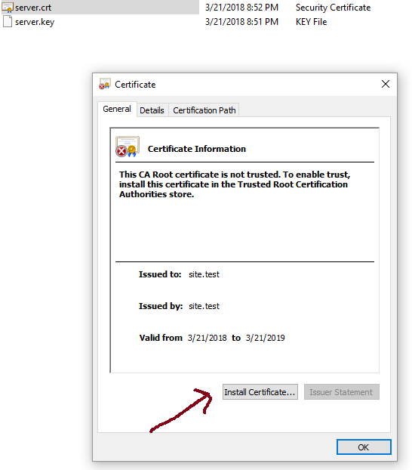

And then select **Local Machine** as Store Location.

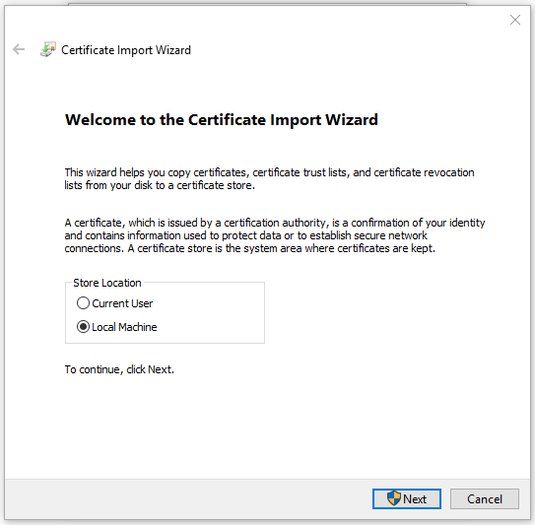

And then Select “**Place all certificate in the following store**” and click **browse** and select Trusted Root Certification Authorities.



Click **Next** and **Finish**.

And now this cert is installed and trusted in Windows.

Step-3 How to setup the XAMPP- (i) xamp ko open krenge aur httpd.conf file me ye changes kar denge.

Listen 192.168.1.237:443

#Listen 80

ServerName localhost:443

(ii) httpd-xamp.conf ko open krenge aur Require all granted kar denge bas

Alias /phpmyadmin "C:/xampp/phpMyAdmin/"

<Directory "C:/xampp/phpMyAdmin">

AllowOverride AuthConfig

Require all granted

ErrorDocument 403 /error/XAMPP_FORBIDDEN.html.var

</Directory>

(iii) windows firewall settings in the inbound rule hum port daal denge 80,8080,443

**Note-** iis setup ko test karne ke liye ki humara setup hua ya nahi. Hum apne webpage me <https://localhost/phpmyadmin> na likhkar ab <https://192.168.1.237/phpmyadmin> ye likhunga aur dekhunga ki mera database open ho rha hai yaa nahi. Ye yad rahe ki isko test krne se pahle mera jo computer hai wo lan cable se connect rahna chahiye.

Step-4 Arduino code ENTRY AND EXIT

ENTRY BARRIER CODE-

#include <SPI.h>

#include <Ethernet.h>

#define relayPin 9

//ENTRY

byte mac[] = {0xDE, 0xAD, 0xBE, 0xEF, 0xFE, 0xED};

IPAddress ip(192, 168, 1, 151);

EthernetServer server(7000);

EthernetClient client;

String clientData = "";

boolean IsClientConnected = false;

boolean IsClientAlive = false;

unsigned long currentMillis, previousMillis, healthPacketMillis, reconnectMillis;

const unsigned long healthPacketInterval = 3000; // 3 seconds

const unsigned long reconnectInterval = 5000; // 5 seconds

void setup() {

  Ethernet.begin(mac, ip);

  server.begin();

  Serial.begin(9600);

  while (!Serial) {

    ; // wait for the serial port to connect, needed for native USB port only

  }

  Serial.print("Machine Gate IP: ");

  Serial.println(Ethernet.localIP());

  pinMode(relayPin, OUTPUT);

  digitalWrite(relayPin, HIGH);

  IsClientConnected = false;

  currentMillis = 0;

  previousMillis = 0;

  healthPacketMillis = 0;

  reconnectMillis = 0;

}

void loop() {

  if (!IsClientConnected) {

    EthernetClient newClient = server.available();

    if (newClient) {

      client = newClient;

      IsClientConnected = true;

      client.flush();

      Serial.println("Client Connected");

      client.println("Connected to Arduino");

    }

  }

  if (IsClientConnected) {

    if (client.available() > 0) {

      char thisChar = client.read();

      if (thisChar == '|') {

        clientData = "";

      } else if (thisChar == '%') {

        Serial.println(clientData);

        if (clientData.equals("OPENEN")) {

          Serial.println("Barrier is opening");

          digitalWrite(relayPin, LOW);

          delay(500);

          digitalWrite(relayPin, HIGH);

          delay(500);

        }

      } else {

        clientData += thisChar;

      }

    }

    // Check and send the health packet every 3 seconds

    currentMillis = millis();

    if (currentMillis - previousMillis >= healthPacketInterval) {

      previousMillis = currentMillis;

      client.println("|HLT%");

    }

    // Check if the client is still connected and reconnect if necessary

    if (!client.connected()) {

      Serial.println("Client Disconnected");

      IsClientConnected = false;

    }

  }

}

Problems:-

**ETHERNET SHIELD RESET ISSUE:** there are two solution for this problem one is hardware solution and the other is software solution.

**Hardware solution:** Ye humari entry ki file hai coding ki isme jo reset ka issue hai usko humne Ethernet shield se solve kiya hai usme register lagakar. 47 ohm kay a phir iski jagah par 56 ohms ka bhi use kar sakte hai. Agar ye nahi hai to hum 100ohm ka ek resistor lenge aur usko 1 aur 2 pin par laga denge. Aur dusre 100 ohm ke resistor ko 3 aur 6 pins par laga denge.

Note- agar hum registor ko dusri sides par lgate hai to kuch resistor aur capacitor jalne ka khatara rahta hai. Usse bachne ke liye hum kya krenge ki hume dusri side par lgane ki jarurat hi nahi hai. Hum agar bas pichhe bhi resistor lgakar chor denge to bhi ye shield kaam karne lag jati hai.

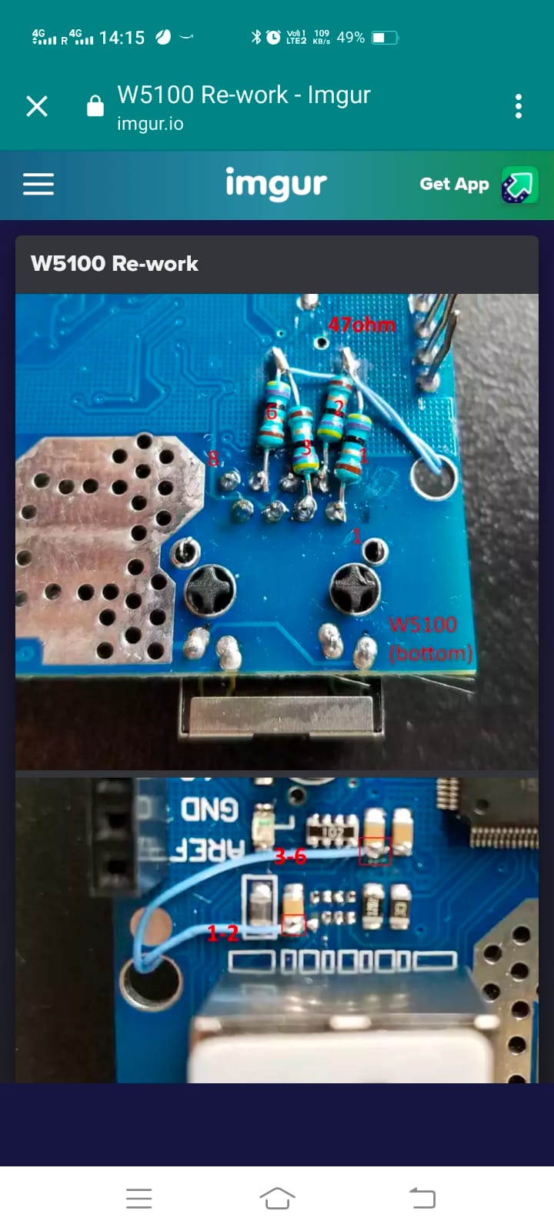

Software solution: hum watch dog timer ka use krenge taki agar humara code kahi fas rha ho aur wo kisi loop me fans kar stuck ho jaa rha ho to ye watch dog timer hume waha se bahar nikal dega and it works fine. So hum ise badhe wale Ethernet shield ke sath bhi testing kiye hai aur jo humara Ethernet module hai w5500 uske sath bhi test kar chuke hai aur ye perfectly kaam karta hai.

#include <SPI.h>

#include <Ethernet.h>

#include <avr/wdt.h> // Include the watchdog library

#define relayPin 9

byte mac[] = {0xDE, 0xAD, 0xBE, 0xEF, 0xFE, 0xED};

IPAddress ip(192, 168, 1, 151);

EthernetServer server(7000);

EthernetClient client;

String clientData = "";

boolean IsClientConnected = false;

unsigned long currentMillis, previousMillis, reconnectMillis;

const unsigned long healthPacketInterval = 3000; // 3 seconds

const unsigned long reconnectInterval = 5000;   // 5 seconds

void setup() {

  Ethernet.begin(mac, ip);

  server.begin();

  Serial.begin(9600);

  while (!Serial) {

    ; // wait for the serial port to connect, needed for native USB port only

  }

  Serial.print("Machine Gate IP: ");

  Serial.println(Ethernet.localIP());

  pinMode(relayPin, OUTPUT);

  digitalWrite(relayPin, HIGH);

  // Enable the watchdog timer to reset the Arduino upon power interruption

  wdt_enable(WDTO_4S); // 4-second timeout

  IsClientConnected = false;

  currentMillis = 0;

  previousMillis = 0;

  reconnectMillis = 0;

}

void loop() {

  // Reset the watchdog timer to prevent reset upon normal operation

  wdt_reset();

  if (!IsClientConnected) {

    if (!client.connected()) {

      client.stop(); // Ensure client is disconnected

    }

    EthernetClient newClient = server.available();

    if (newClient) {

      client = newClient;

      IsClientConnected = true;

      client.flush();

      Serial.println("Client Connected");

      client.println("Connected to Arduino");

    }

  }

if (IsClientConnected)

{

    if (client.available() > 0)

    {

      char thisChar = client.read();

      if (thisChar == '|')

      {

        clientData = "";

      }

      else if (thisChar == '%')

      {

        Serial.println(clientData);

        if (clientData.equals("OPENEN"))

        {

          Serial.println("Barrier is opening");

          digitalWrite(relayPin, LOW);

          delay(500);

          digitalWrite(relayPin, HIGH);

          delay(500);

        }

      } else {

        clientData += thisChar;

      }

    }

    // Check and send the health packet every 3 seconds

    currentMillis = millis();

    if (currentMillis - previousMillis >= healthPacketInterval) {

      previousMillis = currentMillis;

      client.println("|HLT%");

    }

    // Check if the client is still connected, if not, attempt reconnection

    if (!client.connected()) {

      Serial.println("Client Disconnected");

      IsClientConnected = false;

      reconnectMillis = millis();

    }

    // Reconnect if the reconnect interval has passed and the Ethernet link is down

    if (!IsClientConnected && (millis() - reconnectMillis >= reconnectInterval) && (Ethernet.linkStatus() == LinkOFF)) {

      Serial.println("Attempting to reconnect...");

      wdt_enable(WDTO_15MS); // Trigger a reset

      delay(100); // Wait for reset to occur

      server.begin(); // Restart the server

    }

  }

}

Step-5 API hit testing

**Note:** isme hum check krenge ki humne humare projects me jitney bhi endpoint diye hai kya wo link sahi se kaam kar rhe hai. So hum apne system me postman ko download kar lenge.

1. Sabse pahle hum exit.php wali jo humari file hai usme tariffe ko update kar denge site ke hisab se

$tarrifRate = [

'two' => [ '30' => 10, '120' => 15, '180' => 20, '240' => 25, '300' => 30, '360' => 35, '420' => 40, '1440' => 45, '2880' => 90,],

'car' => [ '30' => 20,'120' => 35, '180' => 45,'240' => 55,'300' => 65, '360' => 75, '420' => 85, '1440' => 105, '2880' => 210, ],

'tempo' => ['30' => 20,'120' => 35, '180' => 45,'240' => 55,'300' => 65, '360' => 75, '420' => 85, '1440' => 105, '2880' => 210, ],

'truck' => [ '30' => 30, '120' => 50,'180' => 60, '240' => 70, '300' => 80, '360' => 90,'420' => 100, '1440' => 150, '2880' => 300, ]];

1. Ab hum apni second file jo ki apiCallingInfo.php hai isme update krenge kuch chiz.

$payload = '<etc:ReqPay xmlns:etc="http://npci.org/etc/schema/"><Head msgId="RPA712304L01'.$randomNumber.'" orgId="ROAC" ts="'.$ts.'" ver="1.0" /><Meta /><Txn id="712304L01'.$txnts.'0" note="" orgTxnId="" refId="" refUrl="" ts="'.$ts.'" type="DEBIT"><EntryTxn id="712304L01'.$txnts.'0" ts="'.$ts.'" tsRead="'.$tagInfo['entryts'].'" type="DEBIT" /></Txn><Plaza geoCode="24.618157,73.898504" id="712304" name="UdaipurAirport" subtype="OPEN" type="PARKING"><EntryPlaza geoCode="24.618157,73.898504" id="712304" name="UdaipurAirport" subtype="OPEN" type="PARKING" /><Lane direction="N" id="1" readerId="1" Status="Open" Mode="Normal" laneType="Hybrid" ExitGate="1" Floor="1" /><EntryLane direction="N" id="1" readerId="1" Status="Open" Mode="Normal" laneType="Hybrid" EntryGate="1" Floor="1" /><ReaderVerificationResult publicKeyCVV="" procRestrictionResult="ok" signAuth="VALID" tagVerified="NETC TAG" ts="'.$ts.'" txnCounter="0" txnStatus="SUCCESS" vehicleAuth="UNKNOWN"><TagUserMemory><Detail name="TagSignature" value="'.$tagInfo['signvalue'].'" /><Detail name="TagVRN" value="XXXXXXXXXXXX" /><Detail name="TagVC" value="4" /></TagUserMemory></ReaderVerificationResult></Plaza><Vehicle TID="'.$tagInfo['tid'].'" staticweight="" tagId="'.$tagInfo['tagId'].'" wim=""><VehicleDetails><Detail name="AVC" value="'.$tagInfo['avcvalue'].'" /><Detail name="LPNumber" value="XXXXXXXXXXXX" /></VehicleDetails></Vehicle><Payment><Amount IsOverWeightCharged="FALSE" PaymentMode="Tag" PriceMode="custom" curr="INR" value="'.$tariffAmount.'"><OverwightAmount PaymentMode="Tag" curr="INR" value="0.0" /></Amount></Payment></etc:ReqPay>';

Ok ye udaipur ka main eek payload liya hai make transaction ka. Lekin hume apicallinginfo.php wale files me jis jis function ke liye payload use hua hai un sabhi me changes karne hai jaise orgId, agencyId, airportname, plaza code like 712304 udaipur ka hai, 712305 amritsar ka hai. So jaha jaha bhi 712305 tha maine waha 712304 kar diya, plaza geo code. In sari chizo ko change kar dena hai. Aur in sari chizo ko change karne ke bad hume api hit karna hai. Jitney bhi api ko request krenge unka request ki file ban jayegi request wale folder me sare api ki. Lekin sari api ka response ke liye alag alag unke folder me unka response aayega.

1. API hit-

Tag Id - 34161FA820328BD02043C560

Tid - E28011052000771C380F0AE2

Tag Signature - af9eca07b8c1e94f96636909bd381f4e52b2f3f335d6e86e5e31189ec3ba275b

**a) heartbeat hit api**

https://192.168.1.237/api/entry.php

{

"action":"heartbeat",

"token":"SE9VU1lTLVBBUksyMDIzUFRN"

}

**b) sync time hit api**

https://192.168.1.237/api/entry.php

{

"action":"synctime",

"token":"SE9VU1lTLVBBUksyMDIzUFRN"

}

**c) hit entry api for entry tag testing**

https://192.168.1.237/api/entry.php

{

"action": "vtag",

"tagId": "34161FA820328BD02043C560",

"token": "SE9VU1lTLVBBUksyMDIzUFRN"

}

**d) exit api hit. When I do this means reqpayapi hit**

https://192.168.1.237/api/exit.php

{

"tagid": "34161FA820328BD02043C560",

"token": "SE9VU1lTLVBBUksyMDIzUFRN",

"signvalue":"af9eca07b8c1e94f96636909bd381f4e52b2f3f335d6e86e5e31189ec3ba275b",

"entryts": "2023-11-19 15:03:22",

"tid": "E28011052000771C380F0AE2",

"vehtype": "car/jeep/van",

"tarrifvehtype": "tempo",

"avcvalue": 4

}

e) **checktransaction api hit**

<https://192.168.1.237/api/exit.php>

{

"action":"checktranscation",

"token":"SE9VU1lTLVBBUksyMDIzUFRN",

"txnid":"CD7123047003614512",

"txndate": "2023-12-01"

}

f) notification hit api

<https://192.168.1.237/api/notification.php>

**Note-** sari api hit karne ke bad request aur response ko check karna hai aur un files ko xml se txt me convert krke vikram ko send karna hai successfully api hit karne ke bad.

**NOTE-** so ab agar sari chize sahi se work kar rhi hai to hume ab apne site ko live karne ke liye vikram ki taraf se api end point diya jayega aur live orgId di jayegi. Api end point ko hum update kar denge jo api end point diya hai usse. Apicallinginfo.php wali file me hi in urls ko change karna hai site ko live karne ke liye

$url = "https://fastag-acquirer-inbound.paytmbank.com/ext/api/inbound-mgr/TollPlazaHeartBeat/10";

## So ab site live ho chukka hai ab hum testing kar lenge kisi ke car se entry aur exit karakar ki sari chize kaam kar rhi hai yaa nahi.

**Arduino kota project with Qr scanner-**

#include <SoftwareSerial.h>

#include <SPI.h>

#include <Ethernet.h>

#include <avr/wdt.h> // Include the watchdog library

#define relayPin 9

byte mac[] = {0xDE, 0xAD, 0xBE, 0xEF, 0xFE, 0xED};

IPAddress ip(192, 168, 1, 151);

EthernetServer server(7000);

EthernetClient client;

String clientData = "";

String data="";

boolean IsClientConnected = false;

unsigned long currentMillis, previousMillis, reconnectMillis;

const unsigned long healthPacketInterval = 3000; // 3 seconds

const unsigned long reconnectInterval = 5000;   // 5 seconds

const unsigned long resetInterval = 60000;

String remove_all_repeating_substrings(String input_value) {

  int length = input_value.length();

  for (int i = 1; i <= length / 2; i++) {

    String substr = input_value.substring(0, i);

    int repeat_count = length / i;

    String repeated = "";

    for (int j = 0; j < repeat_count; j++) {

      repeated += substr;

    }

    if (repeated == input_value) {

      return substr;

    }

  }

  return input_value;

}

String extractData(String inputString) {

  if ((inputString.startsWith("QR") || inputString.startsWith("TG")) && inputString.endsWith("END")) {

    String extractedData = inputString.substring(2, inputString.length() - 3);

    return extractedData;

  } else {

    return inputString;

  }

}

bool isNumeric(String str) {

  for (size_t i = 0; i < str.length(); i++) {

    if (!isDigit(str.charAt(i))) {

      return false;

    }

  }

  return true;

}

void setup() {

  Ethernet.begin(mac, ip);

  server.begin();

  Serial.begin(115200);

  while (!Serial) {

    ; // wait for the serial port to connect, needed for native USB port only

  }

  Serial.print("Machine Gate IP: ");

  Serial.println(Ethernet.localIP());

  pinMode(relayPin, OUTPUT);

  digitalWrite(relayPin, HIGH);

  // Enable the watchdog timer to reset the Arduino upon power interruption

  wdt_enable(WDTO_4S); // 4-second timeout

  IsClientConnected = false;

  currentMillis = 0;

  previousMillis = 0;

  reconnectMillis = 0;

}

void loop() {

  // Reset the watchdog timer to prevent reset upon normal operation

  wdt_reset();

  if (!IsClientConnected) {

    if (!client.connected()) {

      client.stop(); // Ensure client is disconnected

    }

    EthernetClient newClient = server.available();

    if (newClient) {

      client = newClient;

      IsClientConnected = true;

      client.flush();

      Serial.println("Client Connected");

      client.println("Connected to Arduino");

    }

  }

  if (IsClientConnected) {

    if (client.available() > 0) {

      char thisChar = client.read();

      if (thisChar == '|') {

        clientData = "";

      } else if (thisChar == '%') {

        Serial.println(clientData);

        if (clientData.equals("OPENEN")) {

          Serial.println("Barrier is opening");

          digitalWrite(relayPin, LOW);

          delay(300);

          digitalWrite(relayPin, HIGH);

        }

      } else {

        clientData += thisChar;

      }

    }

    if (Serial.available()) {

      data = Serial.readStringUntil('\n');

      Serial.println(data);

      String result = remove_all_repeating_substrings(data);

      String entryData = extractData(result);

      if (isNumeric(entryData)) {

        String sendTagData = "|ENTG-" + entryData + "%";

        client.println(sendTagData);

        Serial.println(sendTagData);

      } else {

        String sendEntryQRData = "|ENQR-" + entryData + "%";

        client.println(sendEntryQRData);

        Serial.println(sendEntryQRData);

      }

    }

    // Check and send the health packet every 3 seconds

    currentMillis = millis();

    if (currentMillis - previousMillis >= healthPacketInterval) {

      previousMillis = currentMillis;

      client.println("|HLT%");

    }

    // Check if the client is still connected, if not, attempt to reconnect

    if (!client.connected()) {

      Serial.println("Client Disconnected");

      IsClientConnected = false;

      reconnectMillis = millis();

    }

    // Reconnect if the reconnect interval has passed and Ethernet link is down

    if ((!client.connected()) && (Ethernet.linkStatus() == LinkOFF)) {

      Serial.println("Attempting to reconnect...");

      wdt_enable(WDTO_15MS); // Trigger a reset

      delay(100); // Wait for reset to occur

      server.begin(); // Restart the server

    }

  }

}

/*

 ye same code jo hai mere esp32 based qr scanner ke liye hai ye bhi work kar rha hai

#include <Arduino.h>

#include <SPI.h>

#include <EthernetLarge.h>

#include <HardwareSerial.h>

#include "esp_task_wdt.h"

#define relayPin 13

HardwareSerial SerialPort(2);

byte mac[] = {0xDE, 0xAD, 0xBE, 0xEF, 0xFE, 0xED};

IPAddress ip(192, 168, 1, 151);

EthernetServer server(7000);

EthernetClient client;

String clientData = "";

String data = "";

boolean IsClientConnected = false;

unsigned long currentMillis, previousMillis, reconnectMillis;

const unsigned long healthPacketInterval = 3000; // 3 seconds

const unsigned long reconnectInterval = 5000;    // 5 seconds

const unsigned long resetInterval = 60000;

String remove_all_repeating_substrings(String input_value)

{

  int length = input_value.length();

  for (int i = 1; i <= length / 2; i++)

  {

    String substr = input_value.substring(0, i);

    int repeat_count = length / i;

    String repeated = "";

    for (int j = 0; j < repeat_count; j++)

    {

      repeated += substr;

    }

    if (repeated == input_value)

    {

      return substr;

    }

  }

  return input_value;

}

String extractData(String inputString)

{

  if ((inputString.startsWith("QR") || inputString.startsWith("TG")) && inputString.endsWith("END"))

  {

    String extractedData = inputString.substring(2, inputString.length() - 3);

    return extractedData;

  }

  else

  {

    return inputString;

  }

}

bool isNumeric(String str)

{

  for (size_t i = 0; i < str.length(); i++)

  {

    if (!isDigit(str.charAt(i)))

    {

      return false;

    }

  }

  return true;

}

void setup()

{

  Ethernet.init(5);

  esp_task_wdt_init(4, true);

  Serial.begin(115200);

  SerialPort.begin(115200,SERIAL_8N1,16,17);

  Ethernet.begin(mac, ip);

  server.begin();

  while (!Serial)

  {

    ; // wait for Serial port to connect

  }

  Serial.print("Machine Gate IP: ");

  Serial.println(ip);

  Ethernet.begin(mac, ip);

  server.begin();

  pinMode(relayPin, OUTPUT);

  digitalWrite(relayPin, HIGH);

  IsClientConnected = false;

  currentMillis = 0;

  previousMillis = 0;

  reconnectMillis = 0;

}

void loop()

{

  esp_task_wdt_reset();

  if (!IsClientConnected)

  {

    if (!client.connected())

    {

      client.stop(); // Ensure client is disconnected

    }

    EthernetClient newClient = server.available();

    if (newClient)

    {

      client = newClient;

      IsClientConnected = true;

      client.flush();

      Serial.println("Client Connected");

      client.println("Connected to ESP32");

    }

  }

  if (IsClientConnected)

  {

    if (client.available() > 0)

    {

      char thisChar = client.read();

      if (thisChar == '|')

      {

        clientData = "";

      }

      else if (thisChar == '%')

      {

        Serial.println(clientData);

        if (clientData.equals("OPENEN"))

        {

          Serial.println("Barrier is opening");

          digitalWrite(relayPin, LOW);

          delay(300);

          digitalWrite(relayPin, HIGH);

        }

      }

      else

      {

        clientData += thisChar;

      }

    }

   if(SerialPort.available())

    {

      data = SerialPort.readString();

      Serial.println(data);

      String result = remove_all_repeating_substrings(data);

      String entryData = extractData(result);

      if (isNumeric(entryData))

      {

        String sendTagData = "|ENTG-" + entryData + "%";

        client.println(sendTagData);

        Serial.println(sendTagData);

      }

      else

      {

        String sendEntryQRData = "|ENQR-" + entryData + "%";

        client.println(sendEntryQRData);

        Serial.println(sendEntryQRData);

      }

    }

    currentMillis = millis();

    if (currentMillis - previousMillis >= healthPacketInterval)

    {

      previousMillis = currentMillis;

      client.println("|HLT%");

    }

    if (!client.connected())

    {

      Serial.println("Client Disconnected");

      IsClientConnected = false;

      reconnectMillis = millis();

    }

    if ((!client.connected()) && (Ethernet.linkStatus() == LinkOFF))

    {

      Serial.println("Attempting to reconnect...");

      delay(100);

      esp_task_wdt_init(15, true);

      server.begin();

    }

  }

}

*/